|  |  |  |  |
| --- | --- | --- | --- |
|  |  |  |  |



**Portsmouth Grammar School**

**Year 9 Rugby Team**

LINK TO MAIN SCHOOL WEBSITE

PICTURE or VIDEO

INFO:

This years year 9 team is headed by Sam Lavery who aims to improve the skills of year 9 on and off the field. He is helping the team keep well trained while also focusing on the aspect of teamwork.

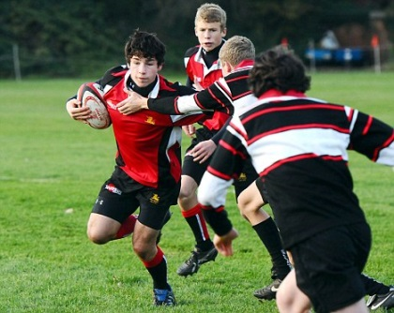

NEWS:

**The Hilsea pitch is due to have fertilizer laid on it on the 22nd of November, so training has been cancelled on the 22nd but will be back on for the next day.**

FIXTURES:

HOME

11:10/Saturday /11 Nov 2017

VS

Seaford College

AWAY

11:10/Saturday/25 Nov 2017

VS

Bryanston School

Show your colours with SOCS sport Team Kit Builder

Show your colours with SOCS sport Team Kit Builder

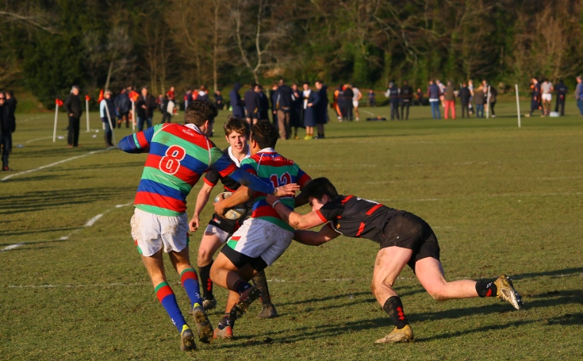



**(The PGS players in action)**